August 2022 Newsletter
First Congregational United Church of Christ
1000 Willson Avenue - Webster City, Iowa 50595
515-832-2232
http://www.firstcongregationalwc.org/

“Everyone, then, who hears these words of mine and acts on them will be like a wise man who built his house on rock. The rain fell, the floods came, and the winds blew and beat on that house, but it did not fall because it had been founded on rock. And everyone who hears these words of mine and does not act on them will be like a foolish man who built his house on sand. The rain fell, and the floods came, and the winds blew and beat against that house, and it fell—and great was its fall!”
Now when Jesus had finished saying these words, the crowds were astounded at his teaching, for he taught them as one having authority, not as one of the scribes.” -- Matthew 7: 24-29

This month’s article is the 5 minute message I offered at our Webster City Ministerial Association’s ecumenical worship service held at the Hamilton County Fair on Sunday, July 24th.

You know, I like to think of myself as a “wise guy:” someone with some smarts; someone savvy about people and life and the world. But as I get older, I am beginning to realize that I am not as wise as I like to I think I am, and I’m beginning to realize that so much of the wisdom that I like to build my life on…is all too human, and not all that wise.
So when we were each asked to offer a short message on the topic “Why Jesus?” I knew I wanted to speak about why I need Jesus as a wisdom teacher: a wisdom teacher who is very well acquainted with my very human wisdom, yet offers me a wisdom that I need to hear—a wisdom that comes from God.
For example, when I start thinking rather highly of myself; when I get puffed up with pride thinking about my accomplishments and successes; when I feel like I am exceptional…a cut above…
Jesus the wisdom teacher reminds me that “The first will be last and the last will be first,” and I hear him say: “Whoever would be great among you must be the servant of all”.
And when I look around me at other people and begin to get judgmental; when I start noticing their clothes, their shape, their hair, their ethnicity, their language, their stuff, where they live and I use what I see to pigeonhole them, to size up their worth, to gauge whether they are my kind of people or not…
Jesus the wisdom teacher reminds me to stop judging, lest I be judged.
When I begin to pick at others; when I criticize them and only see their faults; when I lose my patience with their quirks and their flaws and put them down for just being human…
Jesus the wisdom teacher reminds me to worry less about the speck in others’ eyes…and worry more about the giant plank in my own.
When I begin to become argumentative with others because they don’t think the way I do; when I become angry and let my anger rule my mind and tongue; when I love being snarky; when I never let anyone get the last word in; when I just love to post my comments and opinions on social media and relish the public attacks that make social media such a blood sport….
Jesus the wisdom teacher reminds me to let my words be “yes yes” and “no no,” for anything more than this comes from the evil one.
When money and finances begin to rule my thinking and my life; when I begin to obsess about my bank account and the stock market; when I begin to worry, worry, worry about money, money, money as if my life depends on that, and that alone…when I, like Scrooge, begin to weigh everything in terms of gain and loss…
Jesus the wisdom teacher reminds me that no one can serve two masters. You cannot serve both God, and wealth.
And when my “stuff” begins to rule my thinking and my life; when my closets and attic are bursting at the seams and yet I still bring in more; when “things” become everything to me…
Jesus the wisdom teacher reminds me not to lay up treasure where moth and rust consume, and thieves break in to steal. Rather I am to lay up treasures in heaven, and let the “things of God” be my “everything.”
When my stomach begins to rule my life; when food becomes my dearest friend, and chocolate my sweet savior; when I begin to live to eat rather than eat to live…
Jesus the wisdom teacher reminds me that I do not live by bread alone, but by every word that comes from the mouth of God.
When worry gets the better of me; when I spend sleepless nights wondering what tomorrow is going to bring; when I feel cut off and alone and overwhelmed by the worries that are stealing my peace…
Jesus the wisdom teacher reminds me that I can’t add a single hour to my life by worry; instead, I am to trust God, and seek the Kingdom of God and God’s righteousness…and all else will fall into place.
When I look around me and see so much that is breaking my heart; when I lose heart and stop believing that I can make a difference in a world that has become so polarized, so hateful, so off-track and so hopeless; when I want to hunker down and hide and let the world go to hell in a handbasket…
Jesus the wisdom teacher reminds me that the harvest is plentiful but the laborers are few, and I hear him say “You didn’t choose me but I chose you, and I appointed to you to go and bear good fruit: good fruit this world needs…fruit that will last.”
And finally…when I stop believing that the alpha and the omega of life is LOVE; when I start thinking I can build a life with other things than love: things like hate, anger, revenge, violence, greed, pleasure, fear, worry, self-absorption and “my issues;” when I begin to fall out of love with “Love,” and instead settle for numbness or despair…
Jesus the wisdom teacher reminds me that I am to love the Lord my God with all my heart, soul, mind and strength, and I hear him say to me: “I give you a new way of life: to love one another. As I have loved you, so you must love one another. By this everyone will know that you are my disciples, if you love one another.”
I could go on, but we don’t have time. But what we all do have is a lifetime to build lives that are based on human wisdom, or a higher wisdom…sand, or rock. Why Jesus? Because I need a wisdom teacher to keep me building on rock! For Jesus came not just to save my soul, but also to save my mind and my heart...so I can build an earthly life that is worthy of the gift of human life: a life built on the rock of God’s wisdom. –Pastor Craig

CHURCH OFFICE HOURS

M 8 am - 1 pm

T 9 am – 1 pm

W 8 am – 4:30 pm

Th 8 am – 4:30 pm

F 9 am – 1 pm

Church Staff

Rev. Craig Blaufuss, Pastor
Office: 832-2232 Cell 297-4316
Pastor’s email: revcraigblaufuss@gmail.com
Michele Omvig: Admin. Assist. 269-7210
Church’s e-mail: administrative.office@fcuccwc.org
Dale Olson: Stephen Ministry Ldr 839-5619
Sunshine Duffy: Choir Director 835-7626
Melissa Hindt: Organist 712-351-1074
Curt/Lorraine McCoskey: Cust’s. 832-5341
Tracy Wehrhan: Church Treasurer 297-0370
Dale Olson: Financial Secretary 839-5619

HAPPY BIRTHDAY TO:
1 - Madison Babington
2 - Bruce Perry
5 - Patty Gescheidler
7 - Richard Tudor II
12 - Jan Carden
12 - Howard Stearns
15 - Audrey Burtnett
15 - Laurie Epps
16 - Tom Riemenschneider
18 - Debbie Jaycox
19 - Allison Yungclas
19 - Mary Van Diest
20 - Chad Elkin
21 - Mark Carlson
21 - Mary Worthington
24 - Nick Oberender
27 - Shari Rothrock
31 - Betty Ploeger
31 - Margy Wood

HAPPY ANNIVERSARY TO:
11 - Luverne & Verna Bierle
11 - Mark & Jennie Brim
23 - Don & Gretchen Bruner
31 - Jason & Amanda (Maass) Strahl

Parish Nurse News
Great grilling starts with safety.
Place the grill at least 10 feet away from your house, shrubs, or bushes.
Never leave a grill unattended.
If using a gas grill, check connections thoroughly before use.
Keep a fire extinguisher handy.
Never bring a grill indoors.
Remove grease buildup from grates and trays.
Use utensils with long handles.
Allow the grill to cool before cleaning or discarding charcoal.

Scholarships
On Sunday, July 31 we awarded the following scholarships:
Bess Lyons - 8 scholarships for $ 265.00 Kamryn Pruisman, Carl Swanson, Karl Heimberger, Hannah Stirling, Isabella Nelson, Riley Nelson, Brynne Crystal, and Connor Crystal.
Helen Poole – 2 scholarships for $ 550.00 Jackson Leman and Lauren Leman
Ptacek Medical Careers – 2 scholarships for $ 1,000.00 Ben Sterler and Kylie Crystal
Helen Johnson – 3 scholarships for $ 1,300.00 Jackson Leman, Lauren Leman and Carl Swanson
Faith at the Fair July 24
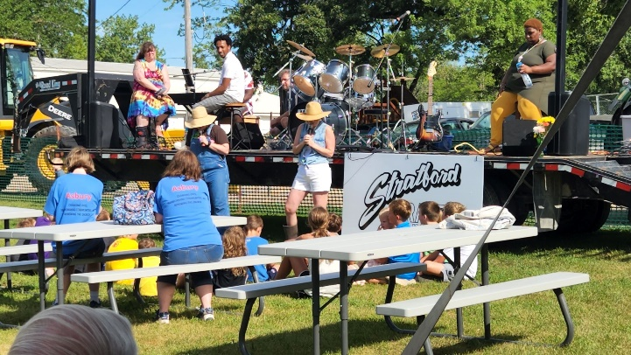

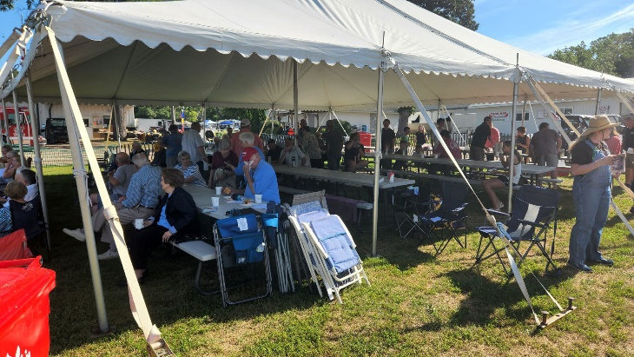
Thanks!
Thank you to the First Congregational United Church of Christ - Webster City for your donation in the amount of $1,542 to support local food pantries through our Food Pantry Challenge. Monies donated were part of their Brownie Sundae Drive-Thru fundraiser held on June 17, 2022. Presenting the check to Darcy Swon, EHCF Director, is Stephanie Hill, First Congregational United Church of Christ member. The Food Pantry Challenge runs through the end of September. Donations will be matched dollar-for-dollar through the generosity of an anonymous donor and the EHCF.

Sunday, August 7 is Confirmation Sunday! On this day confirmand Hailey Brim will publicly affirm her baptism, proclaim her faith, and join our church as an adult member! Communion will be served, and following the service the Christian Ed Board will host a reception in Hailey’s honor.

Summer Worship Hours and Saturday Service Date
Our summer worship hours will remain at 10:00 am. During August we will hold 1 more Saturday evening services: August 27. Saturday service will begin at 5 p.m., and following our Saturday service there will be no Sunday morning worship service that weekend.

Church Wedding
Chase Berhow and Carlee Yates will be married in our sanctuary on Saturday, August 6, beginning at 3:30 p.m., with a reception to follow at Briggs Woods Conference Center. Their wedding rehearsal will be held here on Friday, August 5, beginning at 4 p.m. We wish Chase and Carlee every happiness as they join their lives together in holy matrimony!

UCC Annual Meeting
This year’s meeting will take place in Sioux City, Iowa on October 9-11. Contact Joyce by July 8 if you are interested in attending.

Treasurer’s Report
INCOME June YEAR TO DATE
Pledges and Offerings $11,398.00 $88,165.52
Other Income 0.00 .00
TOTAL INCOME $11,398.00 $88,165.52
EXPENSES
Outreach and Mission 1,416.67 $8,499.98
Pastoral Services 8,046.50 49,142.40
Maintenance and Repairs 4,296.76 20,662.44
Church Office 2,868.18 17,683.94
Music Ministry 238.35 2,215.30
Christian Education 0.00 38.79
Local Ministry 350.00 539.98
Misc. Expenses 285.19 903.97
TOTAL EXPENSES $17,501.65 $99,686.80

FIRST CONGREGATIONAL UNITED CHURCH OF CHRIST
Webster City, Iowa
Cabinet Meeting held on July 12, 2022

Members Present:
Moderator: Joyce Gelhaus Pastor: Craig Blaufuss
Vice Moderator: Wil Groves Trustees: Nick Oberender
Finance Sec.: Dale Olson Women’s Fellowship: Joyce Gelhaus
Finance : Tracy Wehrhan Mission: Gayle Olson
Staff/Parish: Worship: Curt McCoskey
Christian Ed: Vicki Blaufuss Evangelism: Patty Gescheidler
Treasurer: Tracy Wehrhan Clerk: Stephanie Hill

The meeting was called to order at 7:00pm by the Moderator, Joyce Gelhaus in Fellowship Hall. Pastor Craig opened the meeting with a devotional and prayer. (Minutes from the May Cabinet meeting were not read.) Gretchen McGlynn from Worship Board was also present.
Board and Committee Summaries:
Treasurer’s Report: May expenses exceeded offerings by about $4,400.00. June expenses exceeded offerings by $6,000. Tracy Wehrhan moved and Dale Olson seconded a motion that the report be put to audit. The motion passed. Finance Board: Scholarship applications are being reviewed. Scholarship Sunday is July 31st. Board budgets are due September 15th. Christian Education: Will meet on the 13th of July. Evangelism: No report. Mission: Brownie Sundae Drive-Thru was successful at raising $1542 to be sent to Enhance Hamilton County to be matched. Enough donations were received for 13 compete birthday bags. They will be delivered to UDMO. All slots on the sign-up sheet for the Beacon of Hope meal are filled except for 1 cook. In recognition of the great and steady work done through the pandemic, we will treat the Public Health personnel with ice cream sundaes on August 4, 2022 at 2:00pm. Discussion was held about other areas we could either donate to or assist with including the Angel Tree, Lotus, and ADVO Cats. Staff/Parish: No report other than that Pastor Craig will be gone on August 14th. Trustees: The church is being wired for Platinum Connect. Although it is more expensive than Wmtel, the service has more options; we may save on the phone line. The front door is buckling. Joyce Gelhaus spoke to Sean Moran about fixing it. Women’s Fellowship: The Women’s Fellowship booklets are in process. Worship: Has not met for a couple of months. Our next worship service on Saturday, July 25th, will be inside. Pastor’s Report: Pastor Craig extended his thanks to the Worship Board for filling in for him. Southfield is closed to worship services due to Covid. There is no Sunday service on July 24th at UCC, but an ecumenical worship service will be held at the fairground during the fair. There will be a Saturday service on July 23rd at UCC. Hailey Brim will be confirmed on August 7th. And the baptism of the 3 Kennedy children will be on August 27th. The Berhow / Yates wedding will be August 6th at UCC. Pastor Craig will be in Burlington, Iowa on August 14. At the next Christian Education meeting, the lock-in event will be discussed. Susan Andrew’s mother passed away and the service will be held in Mason City on July 22nd.
Old Business:
Constitution Committee: Patti Gescheidler reported that all changes have been input to the Constitution. She will be meeting with her committee.
New Business:
Tri Conference Annual Meeting: The meeting will be October 9th in Sioux City at 5pm through Tuesday, October 11 at noon. There are 2 delegates, Pastor Craig and Marjorie Groves, participating via Zoom. We are entitled to a third delegate.
Emergency plan in case of Pastor Craig’s absence:
Gretchen McGlynn reported that Pastor Craig’s sudden absence last month left the Worship Board off guard. We were fortunate that ministers in town could fill in. A step-by-step plan could be devised for filling this gap. Options include Pulpit Supply, downloading videos, etc. Craig suggested he put together ‘canned’ services and have them available in case of his absence.
Emergency plan in case of Michele Omvig’s absence: It was felt that Michele’s position was also in need of a back-up plan. Patty Gescheidler will determine who we need to have a plan for.
Organ and Piano tuning:
Gretchen McGlynn reports that the organ tuner we’ve used is retiring. Dobson Organ Co in Lake City looked at our organ said the organ at present is good, but that in about 10 years or so the leather straps will need to be replaced at a cost of about $80,000 total. Dobson Organ is willing to tune the organ at the same time he comes for the Trinity organ. But presently he is low on staff and could not begin to service us for 2 years.
The piano is less problematic because the Fort Dodge Choral Society has asked to do a concert here in October 2022 and will pay to tune the piano for that concert.
The meeting was adjourned at 8:10pm.
Next meeting is August 9, 2022 at 7:00pm in Fellowship Hall.
Respectfully submitted,
Stephanie Hill
Church Clerk
BOARD AND COMMITTEE REPORTS
Board of Trustees May Meeting - We had three requests (all approved) for use of the building. A family gathering following a baptism, a small group for quilters and a bridal shower.
Michele alerted us to a sump pump in the nursery room that was running non-stop. Chris McNiel was once again our savior in providing a quick response and fix. The sump pump was monitored for a few days (even after it rained) and it continued to work well. Thank you Michele and Chris!!
Curt McCoskey will be on vacation from June 5th – 11th. Should the church need cleaning issues during this week, please contact one of the Trustees.
With a new provider of trash removal in the area, the Trustees reviewed our current service and options. The decision was made to remain with the current schedule and service provided by The Trashman.
Still on our radar for 2022:
Spring cleaning to be done to the nursery and Sunday School rooms.
Need to replace the electrical panel (located in the ladies’ room) that services the lights in the office and choir room.
Repairs to one outside door to be refurbished by Shawn Moran when weather and time allows.
Potential change to internet service when Platinum Connect is available.
Researching options for new projector equipment in the sanctuary as we anticipate additional breakdowns and most like mandatory replacement in the next year or two.
Board of Trustees June Meeting - An estimate was received from Peterson Construction to replace an electrical panel which is located in the ladies’ room on the main level but affects the lighting throughout the office and choir room. This expense is necessary, is estimated at $3,000, and finance has concurred there are funds available in the Building Fund. The Trustees approved this estimate and asked Peterson Construction to move forward in ordering the supplies.
We continue to be blessed with the dedication of Joyce Gelhaus as she oversees our outside landscaping. Joyce does much of the trimming and clean up by herself but this month she did request – and Trustees approved – to contract with Jim Gatewood to remove a dead bush, trim a few others, and remove the crab apple trees on the south side.
A final review of our lawn care (mowing) and snow removal service was completed. The Trustees believe we are being charged a fair price and receive good service. If nothing warrants concern in the coming years we plan to complete a ‘fresh look review’ every few years just to be sure everything remains well and good.
Still on our radar for 2022:
Deep cleaning to be done to the nursery and Sunday School rooms. (Laurie has volunteered but is likely delayed until August.)
Repairs to one outside door to be refurbished by Shawn Moran when weather and time allows. (A call has been placed to Shawn to get an update on his plans for the door.)
Potential change to internet service when Platinum Connect is available.
Researching options for new projector equipment in the sanctuary as we anticipate additional breakdowns and most like mandatory replacement in the next year or two.
Pastor’s Cabinet Report June 9, 2022 Thank You to everyone who has been so supportive as Vicki and I have gone through our respective health problems. Prayers, cards, calls, meals, time off….we are more appreciative than we can express! I also want to thank Sarah Ostlund for offering her ministry to us while I have been on medical leave, and also Dan Corrow who was willing to conduct Al Fiala’s Memorial service this past Saturday.
Worship: My sudden need for cardiac bypass surgery resulted in some significant changes to our worship schedule! On May 15 I was scheduled to lead care center Sunday afternoon worship services, but I did not due to Vicki’s hospitalization. May 22 was to be Confirmation Sunday, but due to my surgery that date has been postponed, likely until July. On June 5 Pastor Tony Streigle was gracious enough to lead worship, baptize Jeri Lynn Pawletzki, and preside at the Communion table that day! June 12 we were scheduled to baptize Della, Dean and Wynn Kennedy, but those baptisms will need to be rescheduled as well. I am hoping that I will be sufficiently recovered to lead worship on June 19 as we honor our fathers for Father’s Day, and June 25 will be our first Saturday evening worship service in the vacant lot. Weather allowing, we will hold a pet blessing during the service! There will be no worship service on Sunday, June 26 at the church, but I will again lead care center services that afternoon.
Memorial services: Pat Kesler’s memorial service was held May 27th in our sanctuary, with Sarah Ostlund officiating in my absence. Al Fiala’s memorial service was held June 11th in our sanctuary, with Dan Corrow officiating in my absence.
Christian Education: The KLAB students held their last class on May 11 with their annual trip to the Dairy Queen. The Lock-in, scheduled for May 20, has been postponed; no date has yet been set, but I hope we can hold it in July. I will get with Hailey Brim and her parents, and we will set a date for her Confirmation, likely in July. Adult Ed class came to an abrupt halt with my hospitalization, but we only had one week remaining before class would have ended anyway.
WCMA Summer Lunch Program update: Three churches initially signed up for the new summer lunch program to be held at East twin Park: WC Church of Christ, St. Paul Lutheran, and St. Thomas. No one signed up in our congregation to volunteer for this program, so early this week I emailed the WCMA after seeing a promotional piece on the summer lunch program in the Daily Freeman Journal which claimed that 8 churches were participating in the program. Tony Streigle called me to let me know that he and his spouse Robin were taking it upon themselves to hold the program as outlined in the newspaper (Mondays and Fridays from June 6- August 12), filling in on the days when no other church was willing to host the summer lunch. Since that call Asbury UMC agreed to take 2 separate weeks of meals: the week of July 4 and the week of August 1. Tony and Robin are also heading up the cooking classes on Wednesdays during the summer; I have no idea how many youth are participating in that program.
Wedding: Chase Berhow’s wedding is still scheduled for Saturday, August 6 at the church.
The breakdown of my ministry since May 9:
Worship services led:1; Christian Ed:2 ; Meetings:0; Visitation :0
Medical Leave began May 17th
Pastor’s Cabinet Report July 12, 2022 Worship: I resumed leading worship on June 19 as we honored our fathers for Father’s Day, and our fathers were blessed to receive various snack mixes compliments of the Worship Board. On June 25 we held our first Saturday evening worship service in the vacant lot, with a pet blessing! Five dogs were blessed, and several pets were virtually blessed as well. On Sunday, June 26 Don Bruner, Kolleen Taylor and I led care center services at Windsor Manor and Southfield. Crestview is now opened for Sunday afternoon worship services as well, but Southfield recently shut them down for 2 weeks due to covid in the facility. Looking forward: There will be no Sunday service July 24 in our church (due to the Saturday evening service held on July 23,) but on July 24 at 9:30am at the county fairgrounds the WCMA will hold an ecumenical worship service. Scholarship Sunday will be held July 31, and August 7 will be the Confirmation of Hailey Brim, which was postponed from May 22. I will be absent August 14 in order to preach in my home church, and so that Sunday we will have a video sermon. Our last Saturday Evening service will be held August 27, and during that service I will baptize 3 of Maggie and Joel Kenney’s children.
Wedding: Chase Berhow and Carlee Yates have met with me and they will be married in our sanctuary August 6 at 3: 30 pm, with a reception to follow at Briggs Woods Convention Center. Their wedding rehearsal will be held here on Friday August 5, beginning at 4 pm. I am still looking for a sound technician for the rehearsal and wedding; if you are interested, please speak with me.
WCMA Summer Lunch Program update: Summer lunches at East Twin Park continue, with 30-50 lunches distributed on Mondays and Fridays. The program has received $800 in community donations, including our women’s fellowship’s $400 donation. Tony and Robin Streigle continue to hold cooking classes on Wednesdays during the summer at WCCOC; my understanding is that there are upwards of 30 children and youth attending weekly. They have volunteers from their church who are helping with this project. The programs are scheduled to conclude on Friday August 8.
Ecumenical Human Needs Committee: Sharon Perry and Robin Streigle continue to administer the fund, enlisting WCMA pastors to help staff cases. Sharon wrote a grant application to the Teresa Treat Stearns Foundation for the EHC; we have received a $5000 grant from the foundation!
Tri -Conference Annual Meeting: The meeting will be held in Sioux City, Iowa starting Sunday, October 9, beginning at 5 pm, and concluding Tuesday, October 11 at noon. Marjorie Groves is our current lay delegate and I will be attending as a pastor; both of us plan to participate virtually, rather than in-person. We are entitled to one more delegate.
The breakdown of my ministry since June 9:
Worship services led:6; Christian Ed: 0; Meetings:3; Visitation :8

Worship Board: We don’t plan to meet in June but have activities to report. Lined up pastors for a baptism (Tony Streigle) and worship services (Sarah Ostlund and Tony). Lined up pianist/organist in Melissa's absence (Josie Greenley and Kolleen Taylor). Coordinated with Gowrie funeral home and Women's Fellowship for Al Fiala's visitation, service and luncheon, contacting Christy Fiala, making sure officiant, pianist/organist, WF, and custodian received checks. Publicized request for summer music. Gave mums to the women of the church for Mother's Day; Gretchen, Jane and Marjorie are making snack bags for the men for Father's Day. We have Dobson Organ Builders of Lake City coming late June or early July to inspect the organ. They have not agreed to take us on. First they want to check the condition of the organ and determine how much work is needed to maintain the organ. They are short-staffed and not ready to take on large projects at this time. Dobson reported that many organ tuners have retired so they are in short supply now.
Finance Board Meeting Minutes of June 18, 2022 - The board met Sunday June 18 after the church service. We discussed the scholarship applications and the amounts to be given to each applicant. The awards are as follows:
BESS LYONS - 8 scholarships for $ 265.00 Kamryn Pruisman, Carl Swanson, Karl Heimberger, Hannah Stirling, Isabella Nelson, Riley Nelson, Brynne Crystal, and Connor Crystal.
HELEN POOLE – 2 scholarships for $ 550.00 Jackson Leman and Lauren Leman
PTACEK MEDICAL CAREERS – 2 scholarships for $ 1,000.00 Ben Sterler and Kylie Crystal
HELEN JOHNSON – 3 scholarships for $ 1,300.00 Jackson Leman, Lauren Leman and Carl Swanson
Discussion was held concerning scholarship Sunday and we narrowed down to Saturday July 23rd or Sunday July 31st. Tracy discussed these dates with Craig and July 31st the awards will be presented.
Tracy Wehrhan, Treasurer

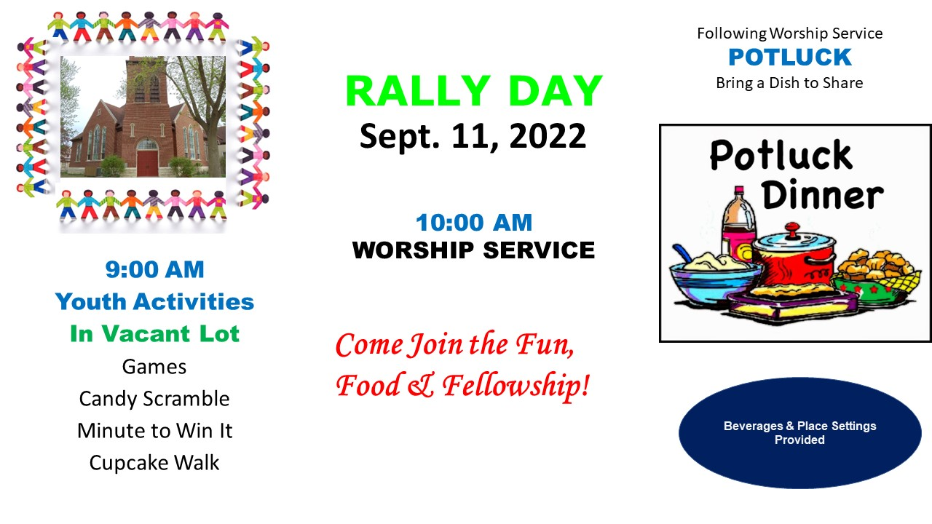

First Congregational United Church of Christ
1000 Willson Avenue
Webster City, IA 50595

Address Service Requested

God is still speaking
to everyone in the home of:

